# **5.6 Guided Exercise: Hashing**

|  |  |
| --- | --- |
| **Resources** | |
| Files | None |
| Machines | Windows 10 |

In this exercise we will use a tool called HashGenerator to generate hashes.

In the Windows 10 machine open the desktop folder called Exercises and then the folder HashGenerator. Double click the file Setup_HashGenerator to install it.

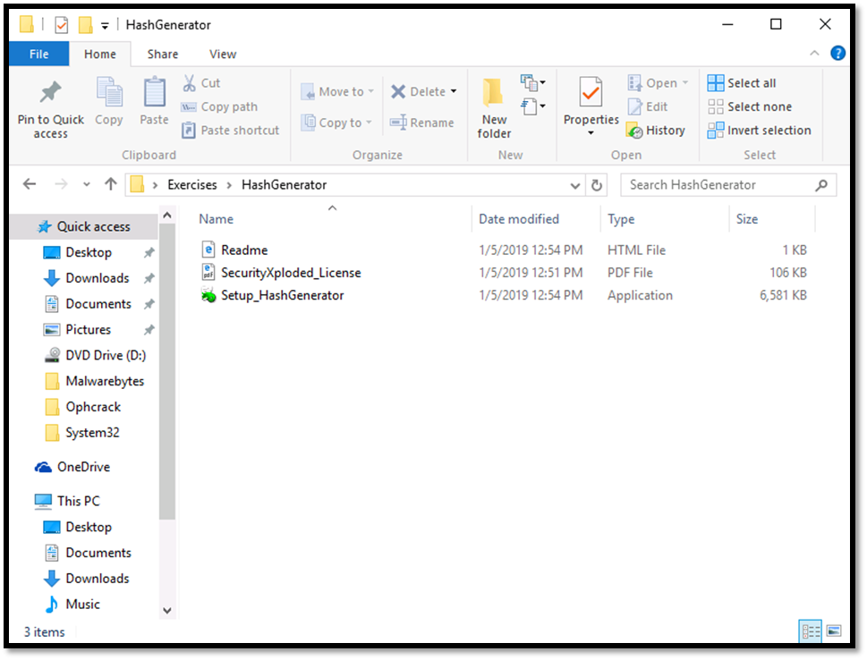

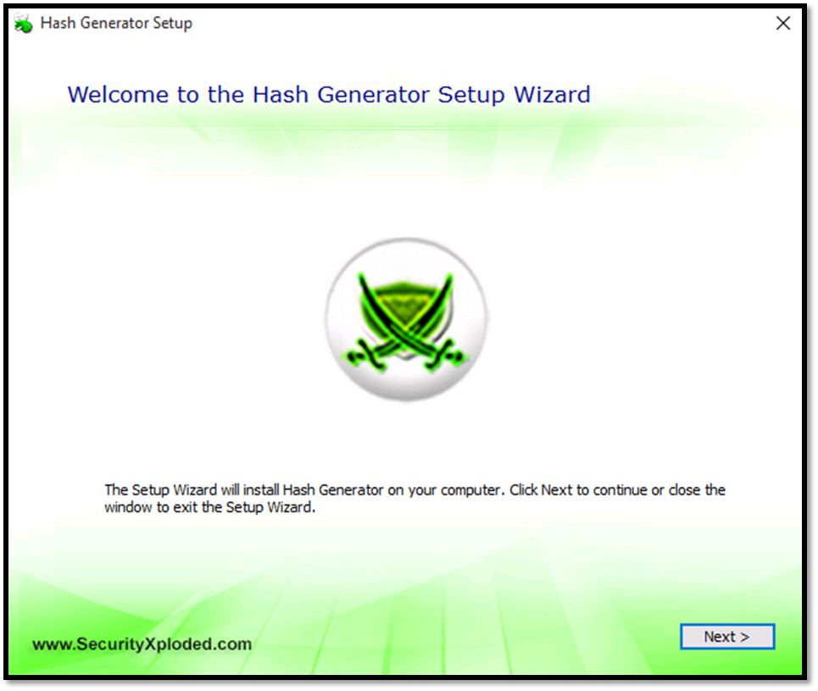

On the Hash Generator Setup window click on Next.

Click again Next on the window Choose a file location.

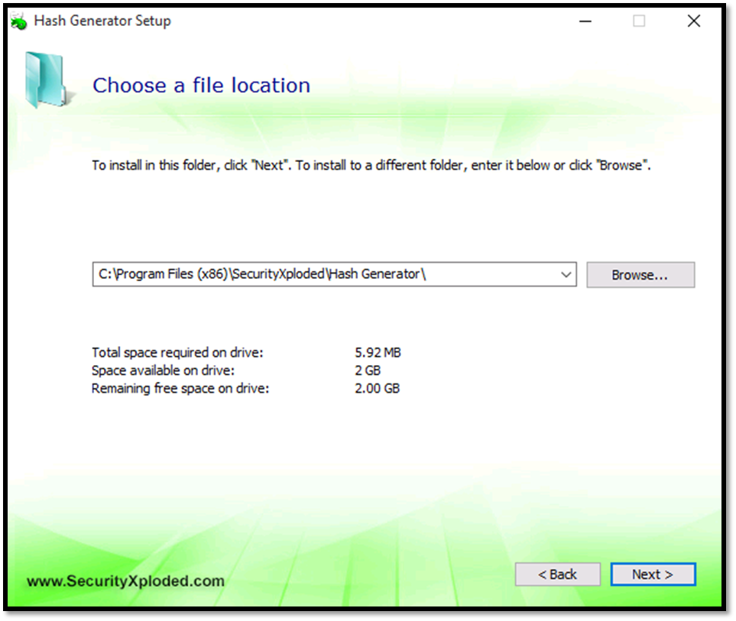

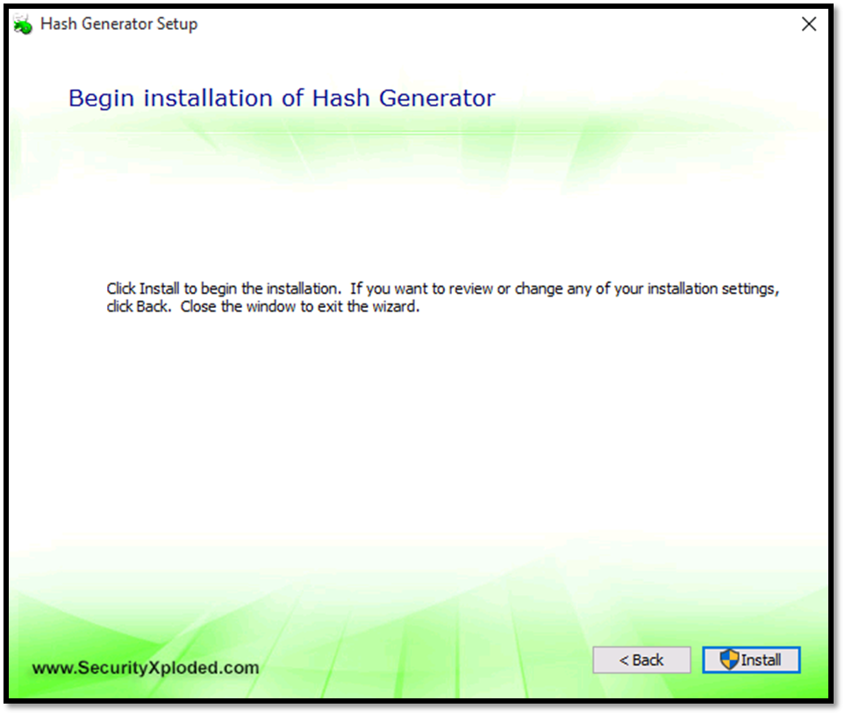

Click Install on the Begin Installation of Hash generator window.

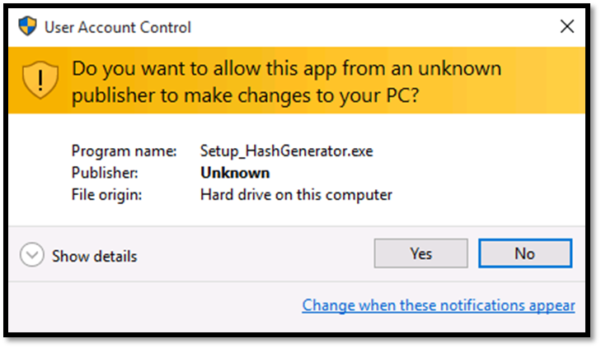

Click Yes on the User Account Control window.

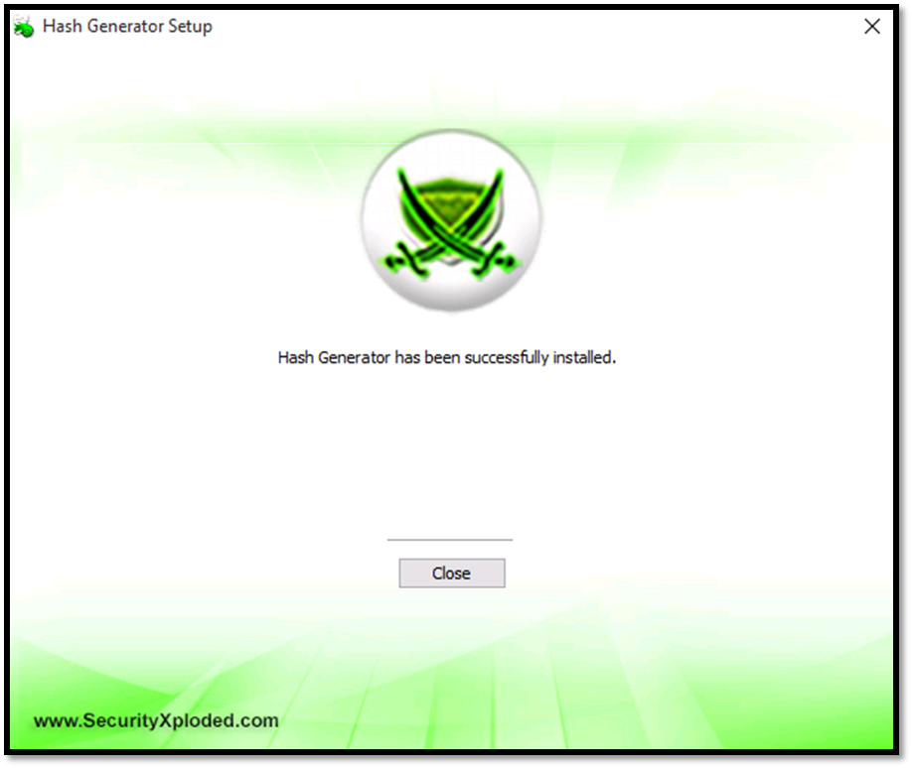Click Close on the Hash Generator Setup window.

On the Hash Generator tool Select Text as the Hash Input Type and the enter the word password on the “Enter or Paste any Text” text box and click on Generate Hash.

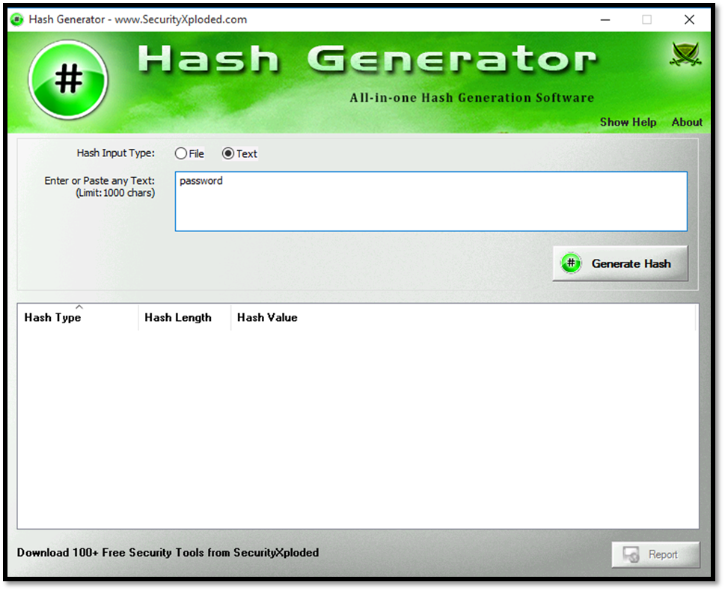

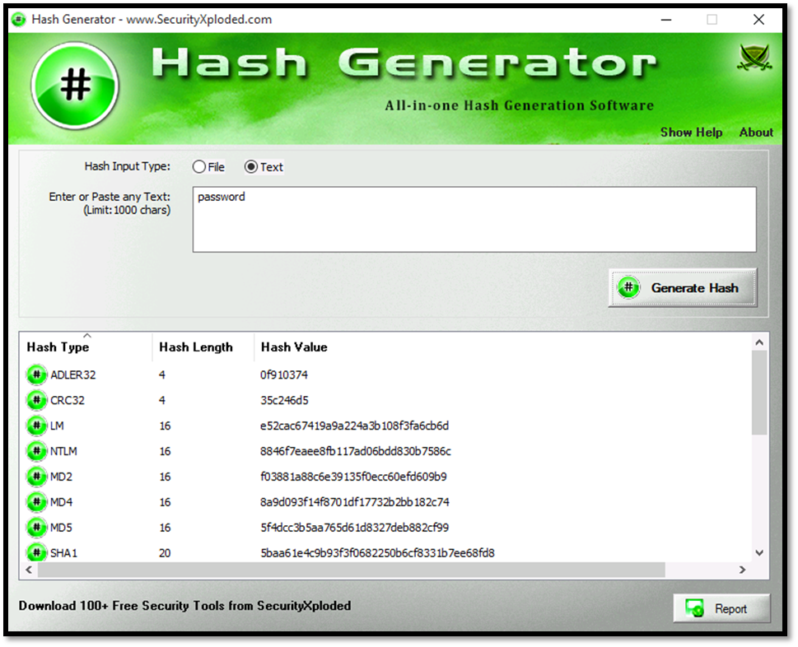

Observe the different types of hashes and the actual hash values.